Yazan ALSHARIF 20200970

Abdallah Younis TARAWNAH 20201188

Mohammad ODAT 20200141

Ibrahim Sanna 20200491

PSUT DATABASE COURS

Online Cinema Booking Database system

2023

-Tables:

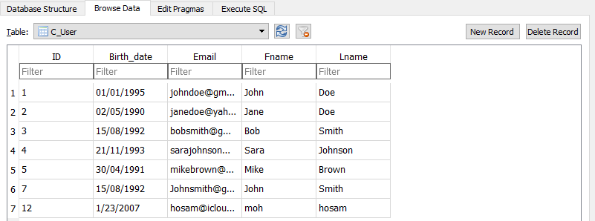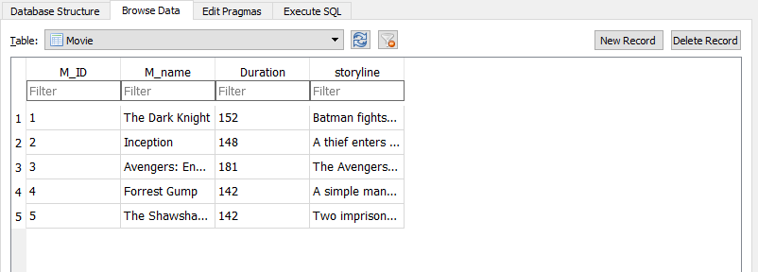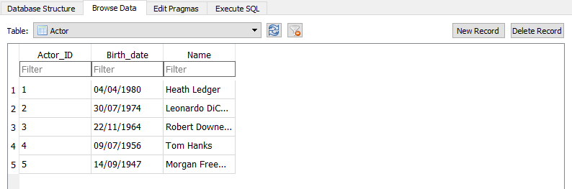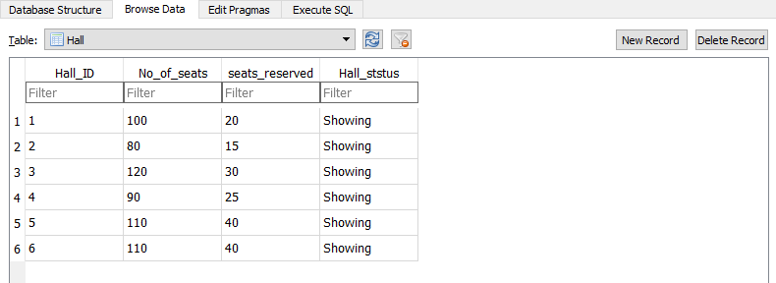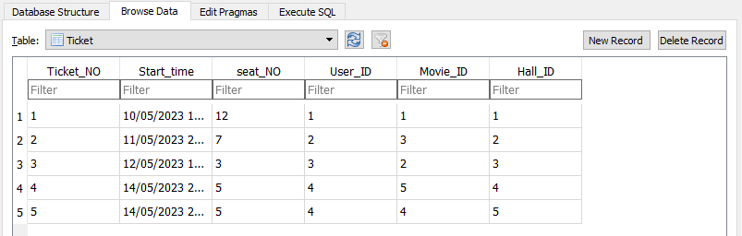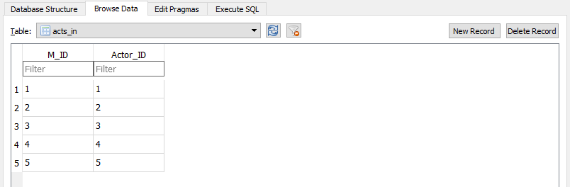

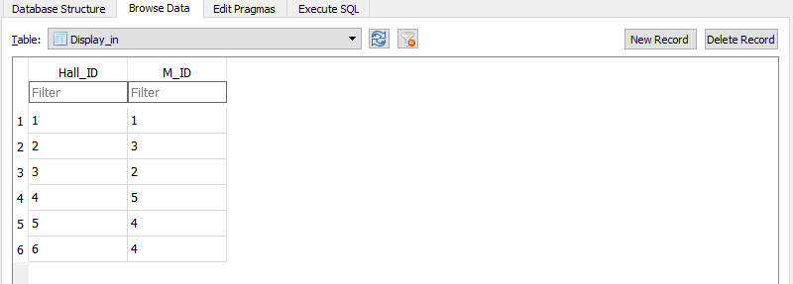

-Tools:

Visual Studio 2022

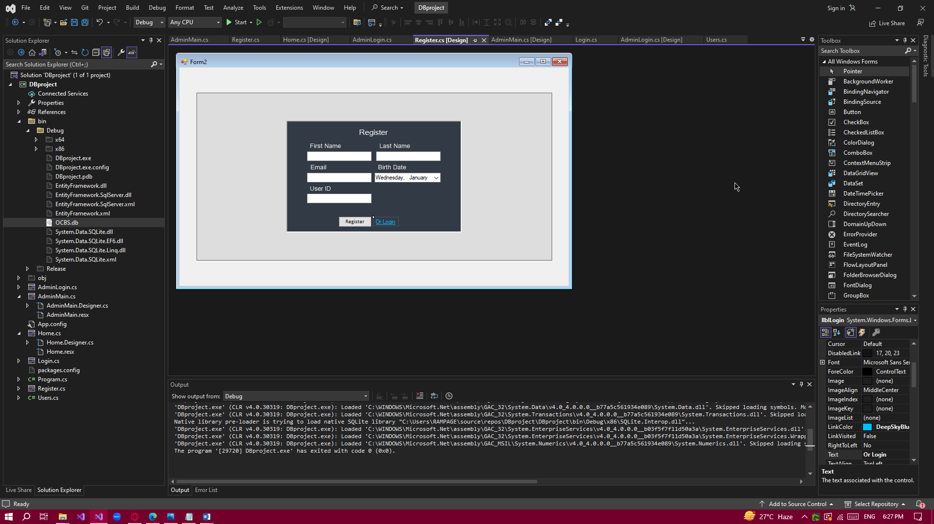

-Library:

System.Data.SQLite.dll

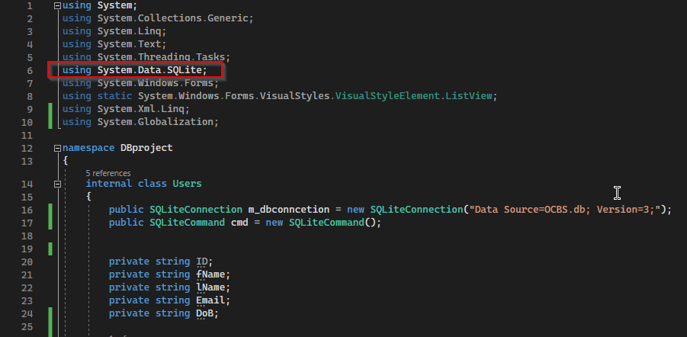

- SQL Server:

DB Browser for SQLite

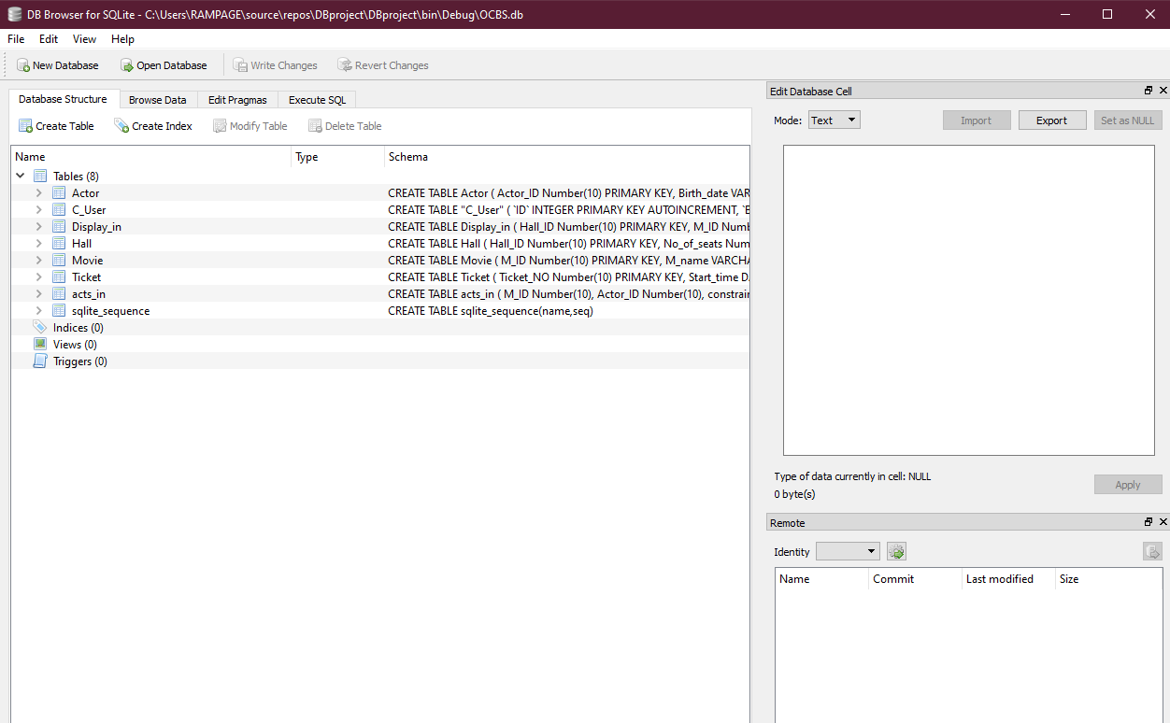

- Insert:

Table before insert:



Interface:

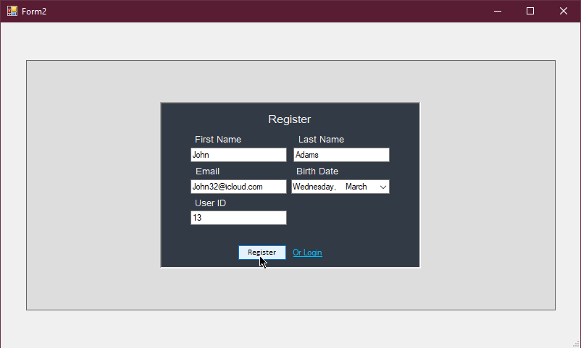

Table after insert:

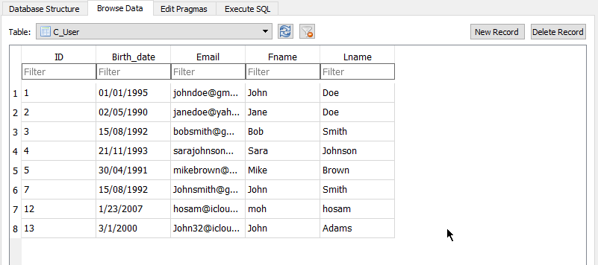

- Search:

Interface before search first name “John”:

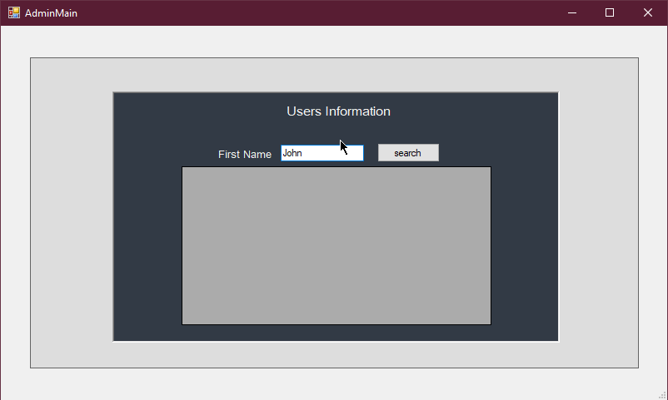

Table before search:



Interface after search:

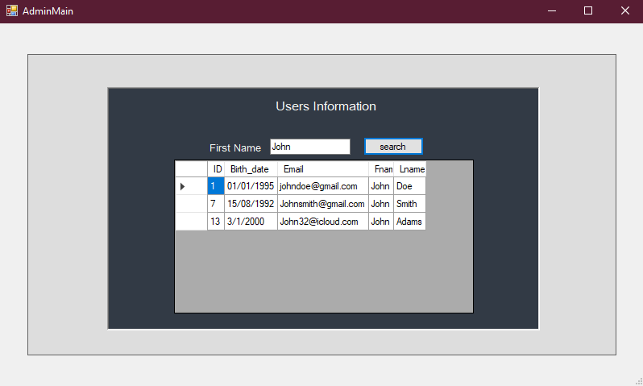

-interface before search first name “Ibrahim”:

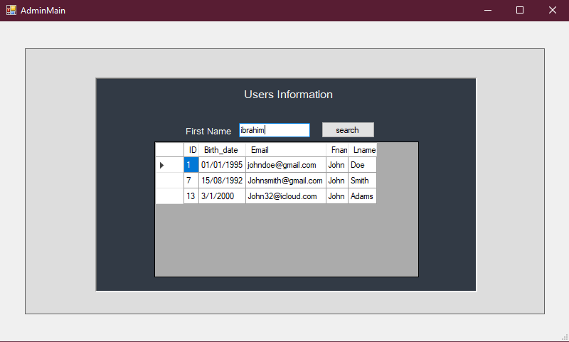

-interface after wrong search:

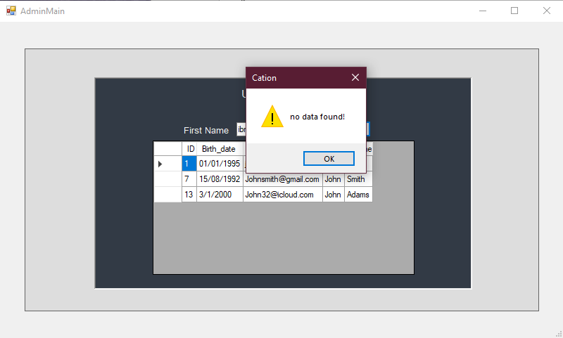

**-Bonus interfaces**

-Login interface with validation:

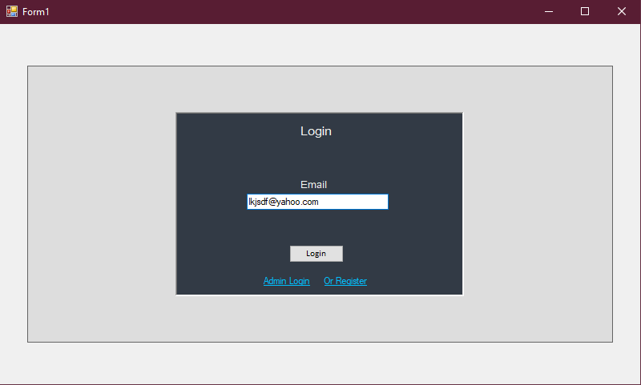

Interface after wrong login:

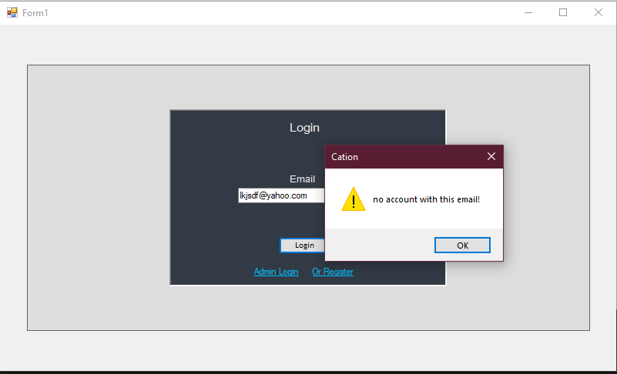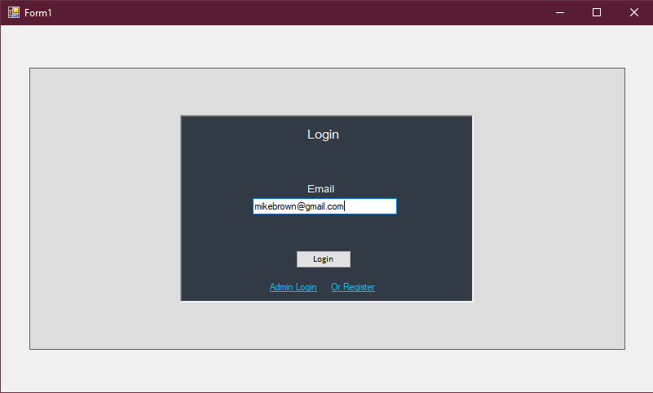

Interface after successful login transfer us to the home page:

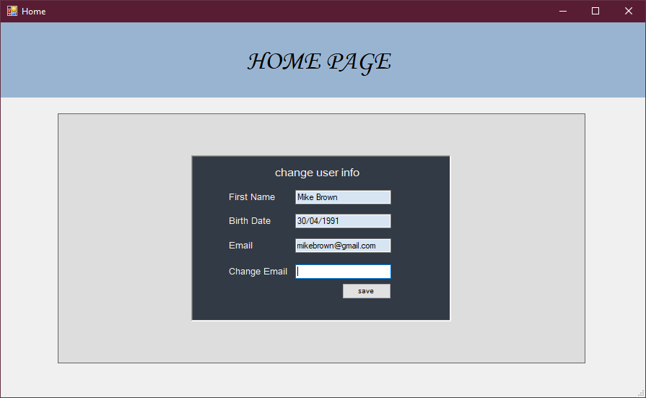

-Home page contains fields with the data of the signed in user and not any other user.

Interface before change:

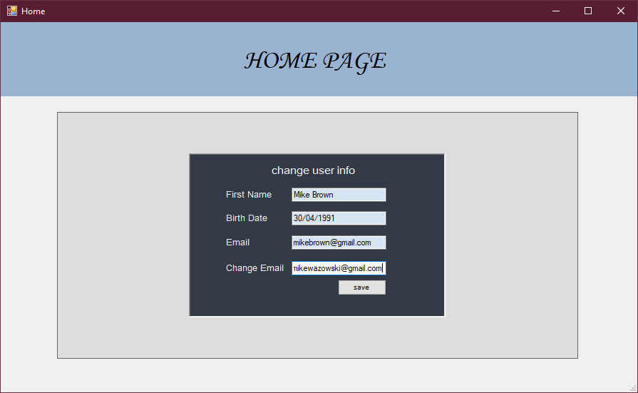

Table before change:



Interface after change:

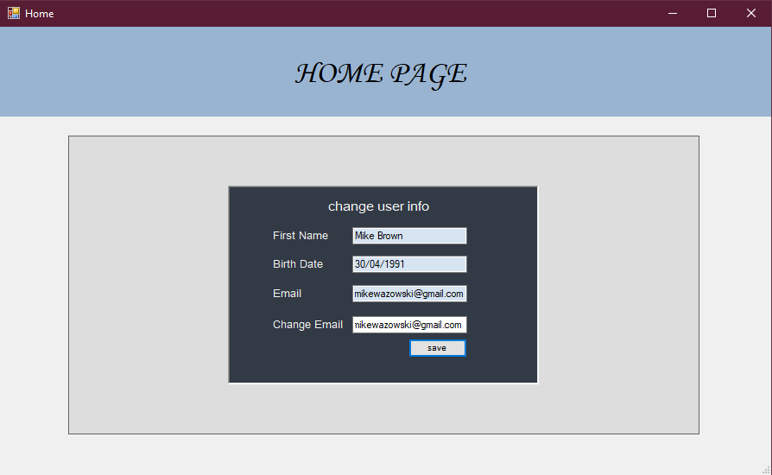

Table after change:

